Chapter 9, Solution 1.

(a) V_{m} = 50 V.
(b) Period 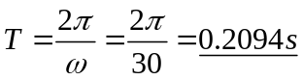 = 209.4ms
(c ) Frequency f = ω/(2π) = 30/(2π) = 4.775 H_{z}.
(d) At t=1ms, v(0.01) = 50cos(30x0.01rad + 10˚)
= 50cos(1.72˚ + 10˚) = 44.48 V and ωt = 0.3 rad.

